**JustDeleteMe**

**Cyber Intel**

# Executive Summary

JustDeleteMe aids users in deleting their accounts from various online services. The tool offers a comprehensive directory, categorizing websites by difficulty level for account deletion and providing direct links to deletion pages. It is beneficial for managing online presence and protecting privacy. However, limitations include potential exclusions of lesser-known platforms, outdated information, and the need to follow additional steps for successful deletion. Overall, while it serves as a valuable resource, caution should be exercised when relying solely on this tool for account removal. The links at the website are tried and tested in the report for easy(DailyMotion) and medium(SourceForge) difficulty category.

# Index

**Executive Summary 2**

**Index 2**

**1. Introduction 2**

**2. Tool Details 2**

**3. Installation 3**

**4. Execution 3**

**5. Scope and Limitations 3**

**6. Conclusion 3**

**7. References (if any) 4**

# Introduction

JustDeleteMe is a website that provides a curated list of links to help users delete their accounts from various online services. It aims to simplify the process of removing personal information and accounts by categorizing each service into different difficulty levels, ranging from easy to impossible. The site also includes color-coded labels indicating whether an account deletion is straightforward or requires additional steps, such as contacting support or sending a written request. JustDeleteMe serves as a useful tool for individuals who want to manage their online presence and privacy effectively.

# Tool Details

Tool available at - <https://justdeleteme.xyz/>

Accessed –

* using Microsoft Edge
* on 23 September 2023
* no VPN required

Use case list –

1. Account Cleanup: Users can utilize JustDeleteMe to easily find and delete accounts they no longer use or want, helping them declutter their online presence.

2. Privacy Management: The tool helps individuals maintain control over their personal information by providing instructions on how to delete accounts and associated data from various services.

3. Simplified Account Deletion: JustDeleteMe categorizes each service based on difficulty level, making it easier for users to prioritize which accounts they want to delete first and identifying those that may require additional steps.

4. Protecting Personal Data: By deleting unnecessary accounts, users can reduce the amount of personal data available online, thereby minimizing potential security risks or privacy breaches.

5. Closure after Data Breaches: In the event of a data breach at a particular service, users can quickly locate that account on JustDeleteMe and follow the provided instructions to close it down as an added precautionary measure.

6. Streamlining Email Subscriptions: Many websites offer email subscriptions that clutter inboxes over time. With JustDeleteMe, users can efficiently unsubscribe from unwanted newsletters or mailing lists by following the deletion process specific to each service.

7. Online Reputation Management: Individuals concerned about their digital footprint can leverage this tool to remove outdated profiles or unused social media accounts that may adversely impact their online reputation.

8. Transitioning Accounts: When switching platforms or moving away from certain services/providers, JustDeleteMe assists in closing old accounts so that users can smoothly transition without leaving behind any lingering traces of personal information.

9 . Staying Informed about Deletion Processes: As new services emerge or existing ones change their account deletion processes, JustDeleteMe strives to stay updated, ensuring users have access to accurate and current information for managing their accounts effectively.

# Installation

No installation required; Fake Name Generator Tool can be directly accessed using a browser by visiting link – <https://justdeleteme.xyz/>

# Execution

* Delete an easy category account – <https://www.dailymotion.com/>

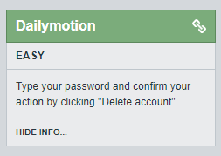

Process of deleting account on easy category site –

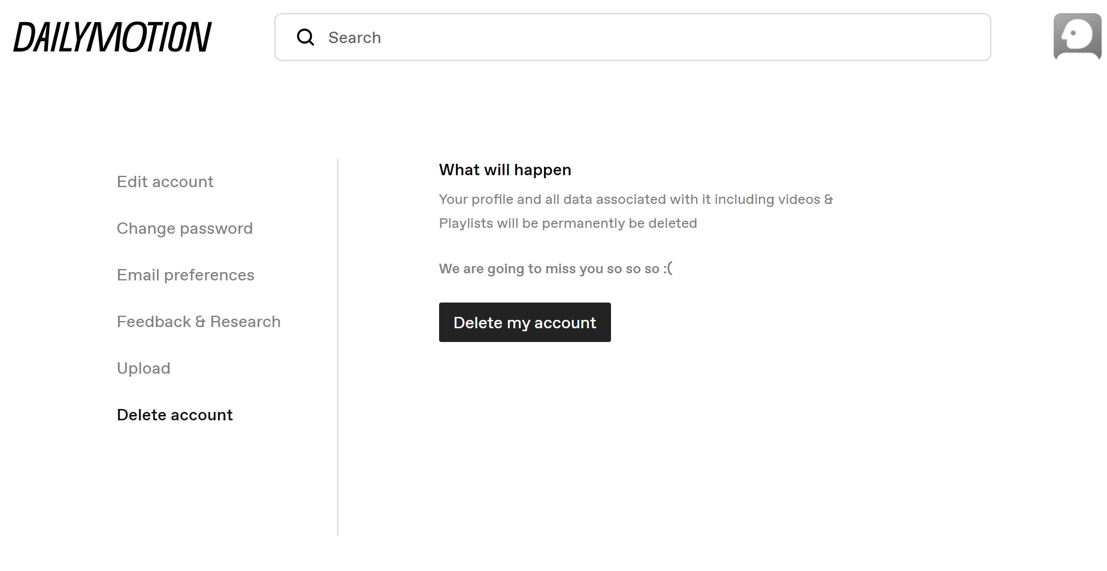

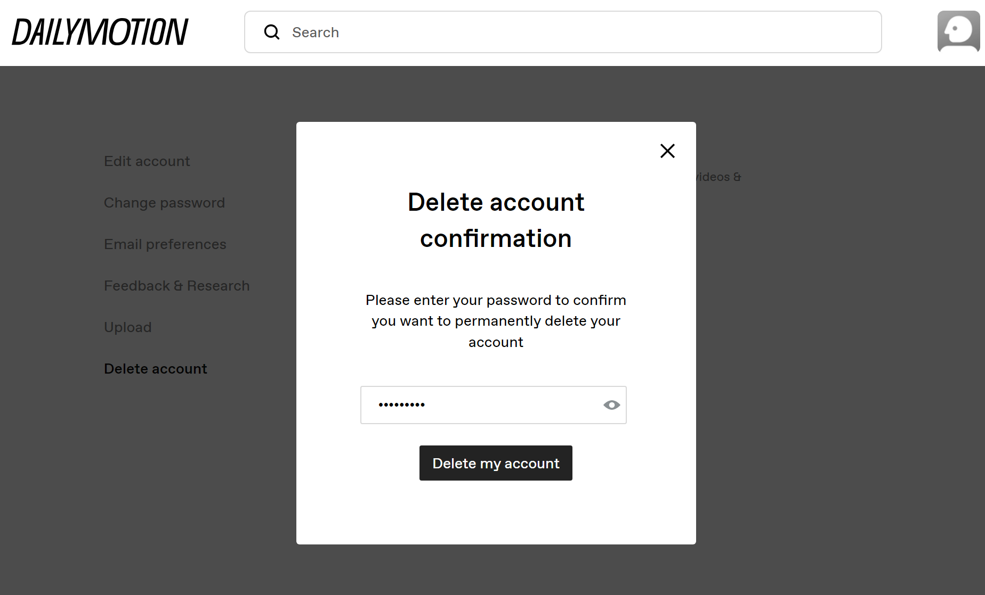

Link to delete the account - <https://www.dailymotion.com/settings/delete-account>

* Delete a medium category account – <https://sourceforge.net/>

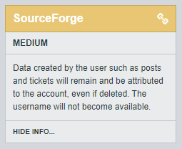

Link to delete the account - <https://sourceforge.net/auth/disable/>

Process of deleting account on easy category site – SourceForge

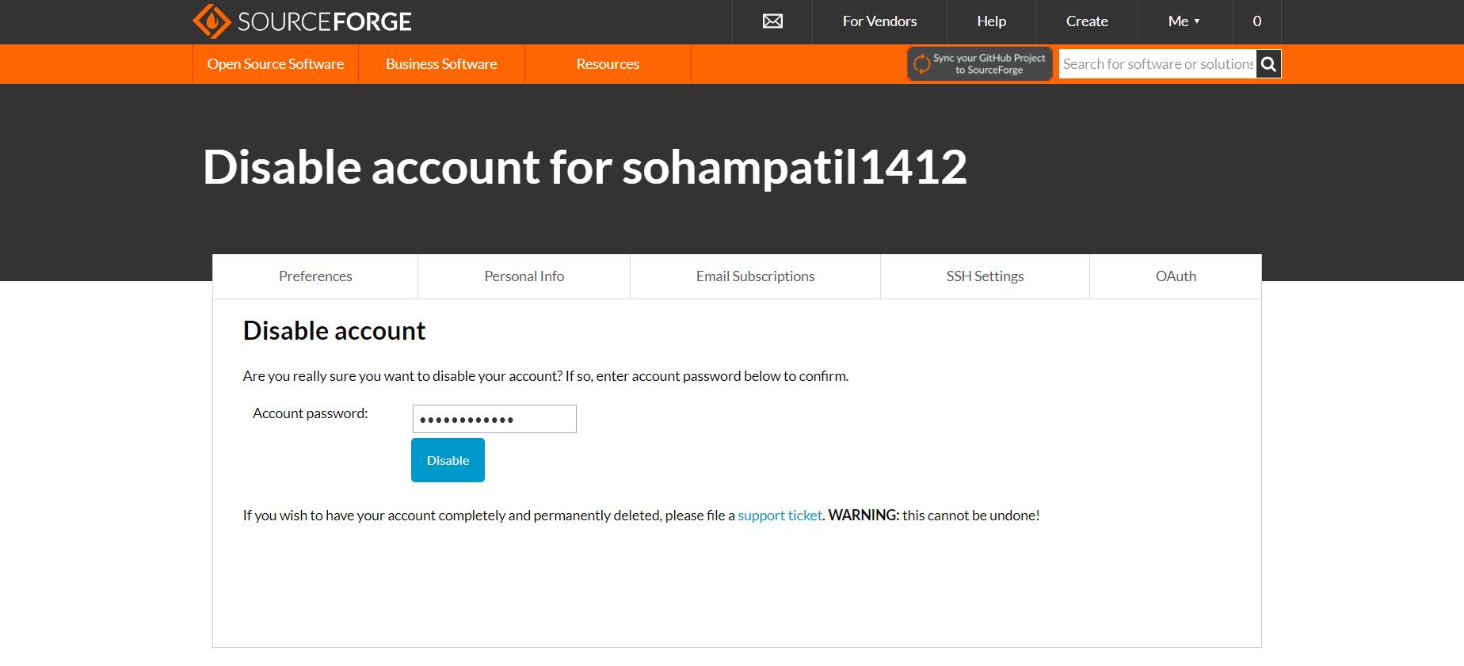

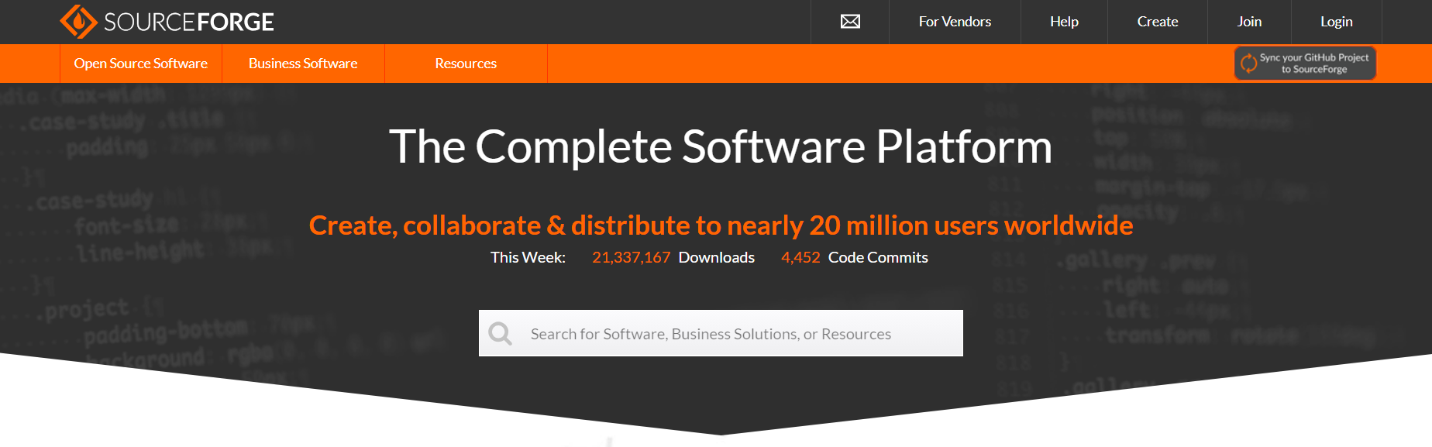

Deleting a hard and impossible account are just as difficult as the category they are classified in. Hard category needs writing an email or contact with the customer care or file a support token to delete the account. While impossible category are the types of account(mostly government or identity verification) which the account provider can only close, disable or deactivate not truly delete the account or its data.

# Scope and Limitations

JustDeleteMe tool covers a wide range of popular websites and online platforms, providing users with convenient access to their account deletion pages. It categorizes the services based on the difficulty level for deleting accounts, helping users prioritize which accounts they want to delete first. The tool provides direct links to the account deletion pages, saving users time and effort in finding them manually.

The directory may not include every website or online service available. Some lesser-known or niche platforms might not be included in the tool's database. Account deletion processes can vary over time as websites update their user interfaces or change their policies. Therefore, some information provided by the tool may become outdated. While the tool provides links to account deletion pages, it cannot guarantee that those links will always work correctly due to changes made by individual websites. Users would still need to follow any additional steps required by specific services for successful account deletion. Simply clicking a link does not guarantee complete removal of personal information from a platform's servers.

# Conclusion

JustDeleteMe offers a valuable solution for individuals looking to delete their accounts from various online services. It provides users with a comprehensive directory of popular websites and platforms, making it easier to navigate and find the account deletion pages. The tool is beneficial in helping users manage their online presence or protect their privacy by removing unnecessary accounts.

# References

* <https://www.justdeleteme.xyz/>
* <https://www.dailymotion.com/>
* <https://www.sourceforge.net/>